**MS Underwater Effect**

**Created by:** Marcos Ismael Schultz

**Age:** 22

**Site:** [www.schultzgames.com](http://www.schultzgames.com)

**Email:** [marcos11-24@hotmail.com](mailto:marcos11-24@hotmail.com)

'MS Underwater Effect' is an extremely easy and intuitive system to use. It was made to create underwater effects easily on any camera.

The system has several effects, such as:

- Distortion of the image

- Image coloring under water

- Droplet effects on the screen

- Image haze under water

- Limitation of vision under water

- Underwater sounds.

**How to use:**

**1** - Add the component "MSUnderWaterEffect" in your player's camera.

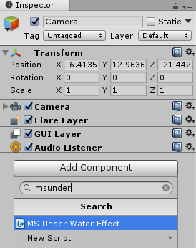

Some extra components will be automatically added to the camera as well. They are required for system operation.



**2** - Now you must adjust the object representing the water in your game. To do this, simply add a collider to your object, delimiting exactly the top surface of the object, as shown below.

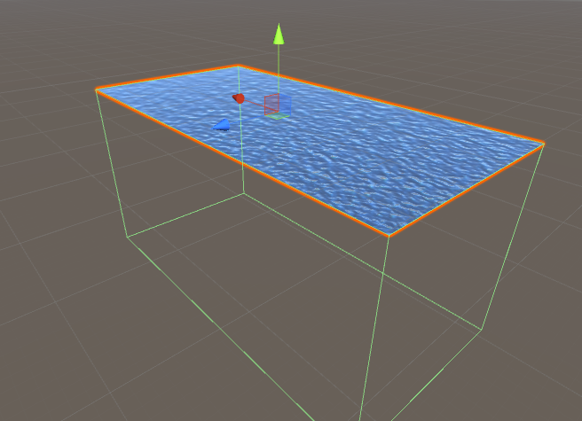

When the camera of your player is within that collider, the effect will be activated. Then you must adjust the collider accordingly.

**3** - After adjusting the collider, you should check the "IsTrigger" option on it, so the camera can use it as a trigger.

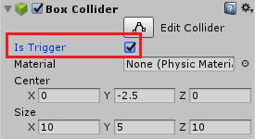

**4** - You should now add a tag for this object that represents the water so that the code can recognize it.

Click "Add Tag"

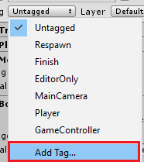

Create a new tag with the name you want.

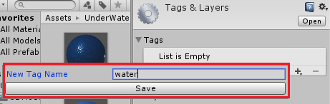

Associate this tag with the object that represents the water in your game, the same object on which you previously added the collider.

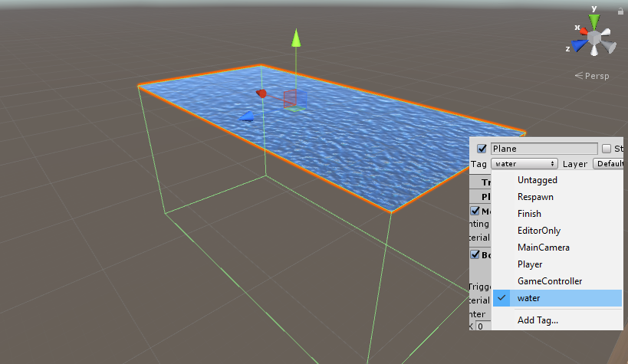

**5** - You should now configure the "MSUnderWaterEffect" component. To do this, simply go to the component and rest the name on the variables. A tip will appear on the screen indicating what each variable does.

To configure the properties of the component, you must enter the characteristics you want for each water. To do this, start the array "waters".

You must enter the number of "water objects" you have in your scene and click "enter" on your keyboard.

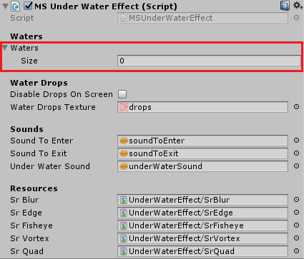

.

A new instance of the class will be created. Now you can configure the various types of water you have in your scene.

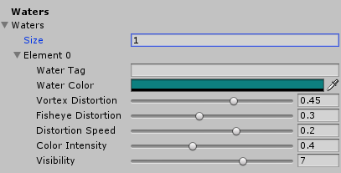

You should just enter the tag of each "water object" and set it up as you wish.

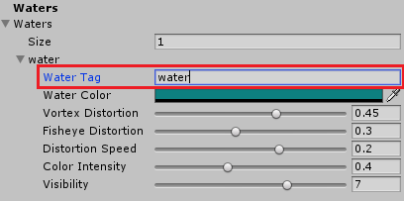

The code still has some sound effects, they are:

Sound when the player goes underwater.

Sound when the player is underwater.

Sound when the player comes out from under the water.